**Title:**

**In view of web application to skin cancerdetection**

**introduce:** Frequent screening of suspicious skin pigmentations is of paramount importance since, at an early stage, skin cancer has a high cure rate and, in most cases, requires a simple treatment. In this paper, we present a new methodology for early detection of skin cancer based on the analysis of a pair of cross-polarization and side-transillumination images to examine surface pigmentation and vascularization characteristics of a lesion. Initially, the two images are automatically segmented by three separate procedures, and then the most accurate results are selected by a scoring stage. Finally, classification of the lesion as malignant or benign is accomplished by measuring the amount of hypervascularity around the pigmented area. When applied to a set of skin lesions, the two-stage methodology provided a 93.3% success rate of correct image segmentation, and it was able to classify correctly lesions as malignant or benign with 86.9% accuracy. The automatic segmentation procedure was validated against expert manual segmentation, whereas the final lesion classification was validated against findings from pathology. These results provide strong support for the importance of transillumination imaging in the early detection of skin cancer.

Psoriasis is a chronic inflammatory skin disease with a high incidence in China. However, in China, especially in rural areas, professional dermatologists who can diagnose psoriasis early and accurately are not enough. If there is an intelligent way to identify psoriasis by images that can be highly adaptable throughout the country, it will play an important role in the early diagnosis and regular treatment of psoriasis. Objective: To design and evaluate an intelligent psoriasis recognition system based on clinical images (independent of dermoscopy) that works similar to a dermatologist. Methods: In the automatic psoriasis identification system, use the convolution neural network (cnns) to build the deep learning model and compare it. This work was performed on a standardized dermatological dataset of 8021 clinical images of nine common diseases including psoriasis and a complete electronic medical record of patients from the country for the past 9 years. In this paper, a two-stage deep neural network was designed and developed for the differential diagnosis of psoriasis. In the first stage, a multi-label classifier is trained to learn the visual pattern for each skin disorder. In the second stage, the first stage is used to distinguish between psoriasis and other skin diseases. Results: The area under the curve (auc) of the two-stage model was 0.981 ± 0.015, which was better than the single-stage model. On 100 clinical images of psoriasis, the classifier had better diagnostic performance (0.03,0.04) than 25 dermatologists (0.19,0.10). Conclusion: The psoriasis clinical image recognition technology based on cnns is feasible and effective, which has laid a solid technical foundation for the remote intelligent nursing application of skin diseases, especially psoriasis in China.

**Index Terms**

Automated image segmentation, Skin cancer

Frequent screening of suspicious skin pigmentations is a very effective approach for detecting skin cancers before they become lethal, since early changes in a malignant nevus typically consist in the development of an irregular pigmentation pattern. However, visual detection of melanomas by a dermatologist has an average diagnostic accuracy of only 58% [4,7], but it can be improved using imaging techniques [31,40], such as oil- immersion [4] and cross-polarization [5] epiluminescence imaging (ELM). In general, these imaging techniques rely on delineating the boundary of a lesion, which is then analyzed for certain skin pigmentation characteristics, such as shape, size, symmetry, color, and texture. To this effect, a number of image segmentation techniques have been proposed in the past several years with varying degrees of success.

Skin diseases are a very common human disease, it will appear in all races and ages, seriously affect the quality of people's life or even endanger people's lives. In this paper, we present a large-scale, Asian-regional-dominated dataset of skin diseases with the bounding box label, namely XiangyaDerm. It contains 107,565 clinical pictures covering 541 skin diseases. Each image in this dataset is marked by a professional physician. To the best of our knowledge, this dataset is the largest clinical image set of skin diseases in Asia and can be used in global computer-aided diagnosis (cad) systems. We compare the classification results (cnns) of several advanced convolutional neural networks on this data set. InceptionResNetV2 Is the best choice for treating 80 skin diseases, the top1 and top3 accuracy reaches 0.588 and 0.764, respectively, which proves the usefulness of the proposed benchmark dataset and gives its baseline performance. The cross-test experiment with the DERM101 dataset shows us that the CNN model has a very different test effect on the datasets of different races. Therefore, to establish a high-performance and high-stability cad system for skin diseases, we propose a dataset of skin diseases for different regions and different ethnic groups.

For example, Umbaugh et al. [39] transformed the original color space of an image into a spherical one that allowed isolating the lesion from the background. In a different study, the same researchers employed the principal component transform (PCT) and the median split algorithm to segment skin tumors [37,38]. The average number of correct detections of the lesion border was between 40% and 60% depending on the color space selected. Hance et

al. [25] compared the effectiveness of six segmentation algorithms in detecting lesion borders. On a test set of 66 images, the lowest average error rate was achieved by adaptive thresholding, which segmented correctly 40 out of 66 images, while the PCT/median-cut algorithm had 46 correct segmentations. However, after combining different methods, the results were further improved to 57 correct segmentations. Xu et al. [41] transformed the color images to intensity images on which the lesion boundaries were then enhanced using a nonlinear sigmoid function. Double-thresholding was used to localize the boundary edges, which were then fitted with a closed elastic curve to get a smooth lesion boundary. Green et al. [24] segmented a set of 204 color images by mapping the image colors to vectors representing the average color and the background of a lesion, and these vectors were then used to determine the threshold corresponding to the lesion border. This resulted in 83.8% correct segmentations. Dhawan et al. [15] used a transformation based on color and texture of an image to extract three components representing intensity, coarse color variation, and fine color texture. Segmentation was initially carried out separately on the different channels and then, partial results were combined to obtain the final segmentation. Ganster et al. [18] combined global thresholding, dynamic thresholding, and 3-D color clustering along with a fusion strategy to identify a lesion and achieved a performance of 96% on a set of 4000 images.

However, several recent studies [2,11,19,20] have shown the importance of angiogenesis for a malignant tumor to grow and proliferate and, in this respect, the above diagnostic imaging techniques miss the most important characteristic associated with malignant lesions. On the other hand, side-transillumination ELM (TLM) is a recent imaging technique in which light is directed from a ring around the periphery of a lesion towards its center at an angle of 45 degrees, forming a virtual light source at a focal point about 1 cm below the surface of the skin [27],

thus making it translucent. The main advantage of TLM is its sensitivity to increased blood flow and vascularization and its ability to visualize the subsurface pigmentation in a nevus. This technique is used by a prototype device, called Nevoscope [13,29], which can produce cross-polarization ELM (XLM) as well as TLM images.

In this paper, we present a methodology for early detection of a malignant lesion based on analysis of a pair of TLM and XLM images, which are used to accurately measure both the pigmentation and vasculature characteristics of the lesion. The next section is dedicated to the description of the methodology, while the following one presents

the results from analyzing a set of 60 pairs of images of malignant and benign lesions. The last section is dedicated to discussing our findings.

II. M ETHODS

data set

The first step is to collect the data. All images were collected by a dermatologist after informed consent from the hospital patients. To obtain high-quality images, a professional digital camera (Canon, resolution: 350 dpi) is used to capture each visual feature of the skin lesion area and maintain sufficient illumination. In addition, images with different scaling levels were collected to acquire fine features such as spatial distribution features and textures. The diversity of datasets is necessary for better generalization performance, so this database contains clinical dermatology images of multiple body parts of the patient.

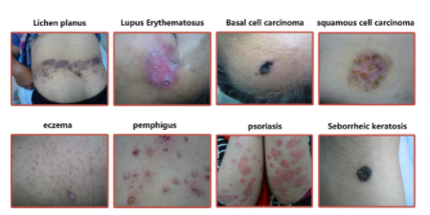

Database sample diagram

The second step is the data filtering and annotation. After data acquisition, we filtered out the substandard images and labeled the remaining images. During data preprocessing, we removed four types of images to obtain a clean dataset: Case1: Skin lesions were occluded or altered by visible local treatment or any other colored residue, which could have a serious adverse impact on the training process. Case2: Special areas, such as fingers, are smaller than normal areas and not clear enough. Case3: Skin is covered with hair or other visual elements, which makes it difficult to extract effective features of the image. Case4: Excessive exudate, resulting in a loss of surface appearance and disease-specific texture. Subsequently, the final standardized experimental dataset was generated by professional dermatologists from Xiangya Hospital working in dermatology for over 10 years to annotate each image based on the corresponding medical records and pathology results. The figure below shows the data filtering and annotation process.Using dermoscopic images as carriers to detect melanoma, conventional calculation The three core problems that need to be solved by the machine-assisted detection method include the lesions Segmentation, feature extraction, and classification. Because the feature extraction can pass through the depth science The practice method is completed automatically, so only two problems need to be solved: suspected cases Lesion segmentation of the images and classification of the lesion tissue. 3.1 Focus segmentation method Lesion segmentation (as in Figure 2) is the task of the ISIC project One, and also the task [13,24] with the most submitted results. Zhang [25], and Bi et al. [26], Bozorgtabar et al [27], Yuan et al [28] have proposed to use full convolutional networks (fully convolutional networks, FCN) to segment the lesion, But in the detail processing is different: Zhang [25] use the image rotation increase Add training set data; Bi et al. [26] proposed combining low-level appearance information And high-level semantic information; Bozorgtabar et al [27] Pixel fine-tuning, using the global lesion information and local texture information; Yuan et al. [28] designed it based on the Jacquard distance (Jaccard distance) The cost function of. The above four algorithms have achieved good segmentation efficiency fruit. Based on the previous study, Yuan et al. [29] proposed to adopt a smaller one Convolution kernel develops convolution-deconvolution network (convolutional-con- volutional neural network, CDNN), added from multiple Color space of color information to facilitate network training, the method in The ISIC dataset tested better than other previous algorithms.Al- masni et al. [30] proposed a fully resolved convolutional network (fullresolution convolutional networks, FrCN), and the network directly learns the input Full resolution features of the data, no need to pre-process or after the image Treatment, in the three evaluation indicators have achieved very good results.He And [31] designed a dense deconvolution network (dense deconvolu- tional network, DDN), combined with a multi-path deep refining network Skin mirror images are trained, and the results are better than the traditional methods

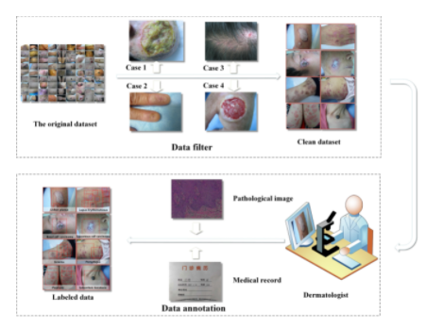

A Schematic representation of the data processing process

A. Data Description

All of the lesions analyzed in this study were imaged using a Nevoscope device capable of obtaining both TLM and XLM images. The device used an optical lens (Nikon, Japan) to achieve a standard 5X magnification and an Olympus C2500 (Olympus, Japan) digital camera for capturing the images. For each lesion two distinct images were acquired, one in the TLM and one in the XLM modality. Clinical imaging was carried out at the University of Texas in Houston under the direction of a board certified physician (MD). Full institutional approvals were obtained for all studies.

A total of 60 lesions were imaged from consecutively and prospectively enrolled clinic patients undergoing routine skin exams, who had clinically suspicious skin lesions of less than 1 cm in size. To avoid clinician bias, all dermatology patients were considered for participation in the study regardless of risk of melanoma or past history.

B. Procedure Outline

The ELM and XLM images undergo completely automated analysis that consists of five main steps, before the lesion in the images can be extracted, classified, and displayed with the lesion boundary outlined. In turn, each main step consists of several sub-steps. The entire procedure is graphically depicted in Figure 1. Initially, the images are preprocessed and segmented with three different methods out of which the final lesion area is selected by a scoring stage. Then, the lesion is classified as malignant or benign by comparing the areas of the lesion in the TML and XTL images. Finally, the refined boundary of the lesion is plotted on the original images.

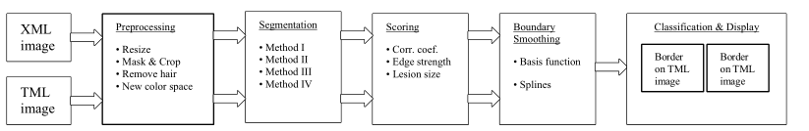

Fig. 1. Outline of the procedure developed for automatic classification of a skin lesion.

C. Preprocessing

Original images have a very high resolution of 1368x1712 pixels and an approximate size of 1.5 MB. To reduce the processing time, images are resized to 256x320 pixels using bicubic interpolation. These values maintain the original aspect ratio of the image.

Furthermore, images have a circular bright ring around the lesion, due to the reflection of light from the edges of the glass plate. To remove this bright circular area, a binary mask with a diameter of 256 pixels is generated, centered over, and multiplied by the lesion to produce a new image, which is then cropped to a square area of 256 x 256 pixels to remove the extra black background around the disc. The hair artifacts can be optionally removed, or minimized, by median filtering the image using two structuring elements of size [1x5] and [5x1]. Finally, to suppress large variations within the background and the lesion, and to reduce the effect of different skin color variations, the original color RGB images are transformed into intensity (grayscale) ones. The separate values of the three color channels (R, G, B) are combined to produce an intensity image (Y) using a commonly accepted transformation, namely Y = 0.3*R + 0.59*G + 0.11*B [24].

Its diagnostic process is the first to pass through Visual observation, followed by dermoscopy, and finally by histopathology Learn to check. Dermoscopes captures skin features and eliminates surface glare because This can effectively assist clinicians in diagnosis, which is early diagnosis, screening And the main carrier for computer-assisted detection. Due to the melanoma and Other pigmented dermatological lesions in the color, texture and margin shape There are similar features and other characteristics, and between different patients There are differences, so that only experienced dermatologists can be accurate Identification identify melanoma and the lack of limitations of experienced dermatologists Large-scale early diagnosis or screening of melanoma

D. Image Segmentation

Four different methods are implemented for image segmentation and they are described in detail below.

D.1 Segmentation Method I

The main objective of this technique is to enhance the edges on the lesion boundary, while suppressing the gradients inside the lesion and in the background. This is accomplished using a nonlinear sigmoid function for remapping the image intensity values that is given by

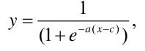

where x and y are pixels in the input and output image, respectively. The parameter ‘a’ controls the slope of the sigmoid, while ‘c’ specifies the input intensity value that will map to the midpoint in the output. Therefore, a significant step in this method is to correctly identify the midpoint ‘c.’ The effect of the sigmoid center on the mapping of the lesion boundary is shown in Figure 2, which shows that if the average intensity of the boundary pixels in the input image is mapped closer to the midpoint ‘c,’ then the boundary pixels in the output image would have a wider intensity range.

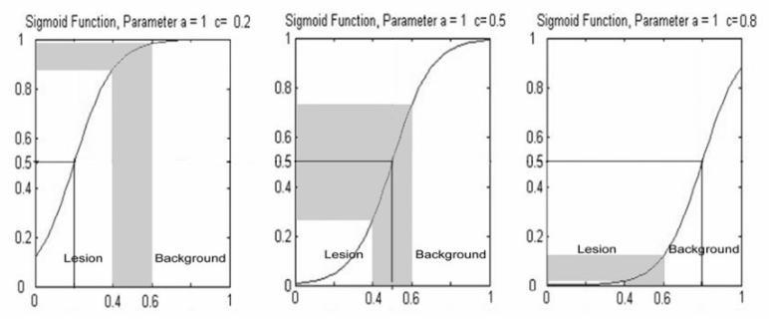

Fig. 2. The effect of the sigmoid center on the mapping of the lesion boundary.

Initial tests with a training set consisting in a subset of 12 randomly selected images showed that the slope‘a’could remain constant for all images, and it was therefore set to a = 0.8. On the other hand, the parameter‘c’, the midpoint of the sigmoid, was image specific. As a representation learning method [16], deep learning can be learned from the original The automatic extraction of features in the starting data changes the manual extraction of features in the past Difficult status quo. Meanwhile, deep learning can be abstracted through simple features construction Features (as shown in Figure 1) that get the computer through simpler concepts Building complex concepts solves the core problem in representation learning This shows a strong fit ability of [17]. Among a variety of deep learning methods, Convolutional neural networks are more suitable for the processing of 2 D images, and therefore also Is the core method of medical image processing. Based on the traditional convolutional network, research The personnel further put forward the residual learning method, used to overcome the deeper Saturation problem of the layer networks. On the basis of a good network structure, the network Training is another important problem for the successful application of deep learning, phase For natural images, the medical image dataset is smaller and therefore generally used Transfer learning methods for training The procedure that selects the value of‘c’automatically for each image is as follows:

(1) The histogram of the image is computed and then smoothed, using a moving average filter with window size equal to three pixels.

(2) The relative maxima of the histogram are determined using a threshold of 1% above the total number of pixels in the image to avoid false detections due to noise.

(3) If only one maximum is detected, it is considered to be the mean (m 1 ) of the Gaussian curve that corresponds to the background. If more than one maximum is detected, the first one is used as the mean (m 2 ) of the lesion Gaussian, and the last one is used as the mean (m 1 ) of the background Gaussian.

(4) The full-width-at-half-maximum (FWHM) values are calculated for the Gaussian curves, and then the standard deviations (s 1 and s 2 ) of the Gaussians are computed from FWHM = 2 √ (2In2) s ≈ 2.36s.

(5) The original histogram is then fitted with the Gaussians.

(6) If only the background Gaussian is detected, the midpoint‘c’of the sigmoid function is determined as the histogram bin at the start of the Gaussian, and in that case, it is equal to (m 1 -3s 1 ). Otherwise, ‘c’ is taken equal to the lower value of either the start of the background Gaussian (m 1 -3s 1 ) or the end of the lesion Gaussian (m 2 +3s 2 ). The resulting value of ‘c’ corresponds to the lesion boundary. An example of fitting the histogram

of an image with two Gaussians is shown in Figure 3.

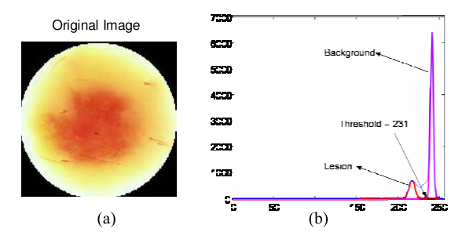

Fig. 3. Example of fitting the histogram of a TLM image (a) with two Gaussians (b) representing intensity values of background and foreground pixels.

(7) The sigmoid transformation is applied to the image, which is then smoothed with [3x3] Gaussian kernel having standard deviation of two pixels, to remove the effect of noise and repetitive texture of the skin.

(8) The nonlinear transformation procedure produces a histogram for the smoothed image that is bimodal and has two distinct peaks. Hence, the method by Otsu [30] can be used to automatically threshold the image and obtain a binary mask that represents only the lesion.

As an example, Figure 4 shows the various steps needed to segment the lesion shown in Figure 3(a) using Method

I.

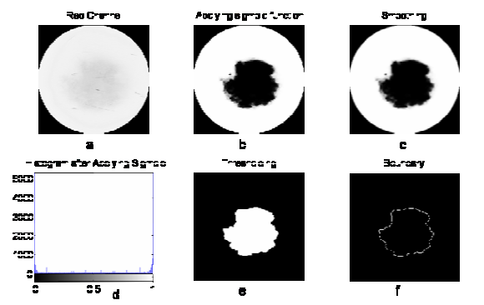

Fig. 4. Various steps implementing Method I on the image of Figure 3(a). (a) Red channel of the image; (b) image after sigmoid transformation; (c) image after boundary smoothing; (d) image histogram; (e) lesion mask; and (f) lesion boundary.

D.2 Segmentation Method II

This method is based on the principal component transformation (PCT) of an image and was originally proposed by Umbaugh et al. [39] and later extended by our group [16,47]. The PCT uses the statistical properties of the image to align the main axis of the intensity distribution values along the direction of maximum variance [37, 38]. The resulting X1 image, which corresponds to the largest principal component, presents the best contrast between lesion and background, with the lesion showing brighter than the background. This method consists in the following steps:

1. Transform the color space from RGB to LAB using the equations::



(2) Calculate the 3-D color covariance matrix, along with the eigenvalue (V) and eigenvector (E) matrices. Then compute three new variables X1, X2, and X3 using [X1, X2, X3] T = E [L, A, B] T .

(3) Invert the grayscale image and add it to the X1 image to saturate the lesion area, which now is completely white (all pixels have a value of 255).

(4) Threshold the resulting saturated image using a value of 250 to get a binary mask, which represents only the lesion.

As an example, Figure 5 shows the various steps needed to segment the lesion shown in Figure 3(a) using Method II.

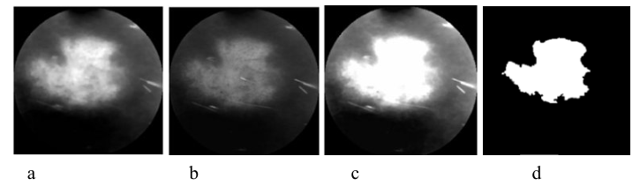

Fig. 5. Various steps implementing Method II on the image of Figure 3 (a) X1 image, (b) inverted grayscale image, (c) saturated lesion, and (d) lesion mask.

D.3 Segmentation Method III

This method addresses an issue with X1 images that show a wide border around the lesion, resulting in a wide range of intensity values, which in turn makes it difficult to compute automatically a fixed threshold from the histogram. The gradient of the X1 image, however, has a relatively narrow range of intensity values regardless of the extent of the lesion border. This method combines Method II with a variant of Method I, which, in this case, requires a different way to compute the midpoint of the sigmoid function. The method is implemented as follows:

(1) Apply the PCT to the color image to get the X1 component, as Method II.

(2) Compute the gradient of the X1 image and use its median intensity value to threshold it. Perform a logical AND operation between the resulting binary image and the X1 image, to obtain the pixels that belong to the boundary region in the X1 image.

(3) Use the median intensity value of these pixels as the midpoint ‘c’ for the sigmoid. The slope parameter ‘a’was found very stable in the test set of images and it was again set at a=0.8.

(4) Transform the X1 image using the sigmoid mapping function used in Method I, and smooth the transformed image using a [3x3] Gaussian filter kernel with standard deviation of two pixels, to remove the effect of image noise and repetitive texture of the skin.

(5) Threshold the resulting saturated image using a value of 250 to get a binary mask, which represents only the lesion.

As an example, Figure 6 shows the various steps needed to segment a lesion using Method III.

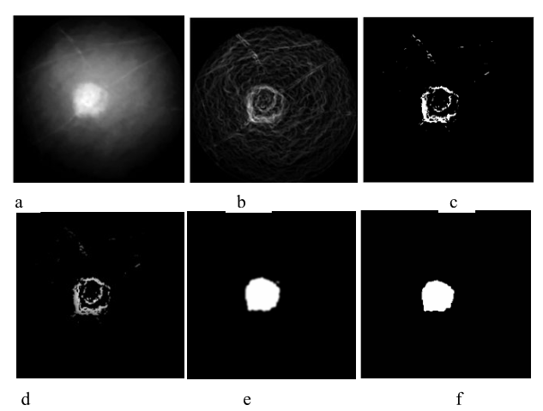

Fig. 6. Various steps implementing Method III. (a) X1 image, (b) gradient of X1 image, (c) boundary gradient mask, (d) multiplying X1 image with mask, (e) sigmoid transformation of X1 image, and (f) final mask D.4 Segmentation Method IV This method is based on a previously developed fuzzy c-means algorithm [17] and a set of ad hoc rules developed by our group [16]. We have used his method successfully to segment PET images of glucose metabolism [47]. FCM clustering requires the specification of two parameters, i.e., the number of clusters and the fuzziness index. Assuming that an image can be divided into three main areas, namely background, lesion boundary, and lesion we selected three clusters, a choice that was confirmed by the test set. The fuzziness index was determined from the test set of images and was set equal to 1.25. The segmentation technique is implemented in the following steps:

(1) Convert the 2-D RGB image into a 1-D grayscale vector by concatenating all the rows in the image.

(2) Cluster the image assuming the presence of three clusters.

(3) Defuzzify the clusters using maximum membership as the defuzzification function.

(4) Identify the lesion cluster as the one that has the highest number of pixels around the lesion center and corresponds to the lesion area.

(5) Separate the lesion cluster from the other clusters. This results in a binary image where only the pixels of the lesion cluster have a value of 1, and all other pixels have a value of 0.

(6) Out of all connected regions in the binary image, select the largest region as a binary mask, which represents only the lesion.

As an example, Figure 7 shows the various steps needed to segment the lesion shown in Figure 3(a) using Method IV.

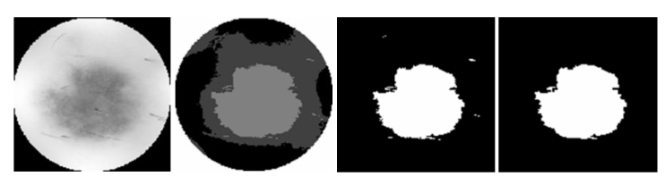

Fig. 7. Implementation of segmentation Method IV. (a) Original image, (b) image after clustering and defuzzification, (c) lesion cluster, and (d) lesion mask.

D.5 Coarse Boundary Computation

Regardless of the method used, at the end of segmentation a binary image (mask) that corresponds to the lesion is defined. Then, the area and boundary of the lesion can be computed as follows:

(1) Perform the morphological operations of dilation, erosion, and bridging on the binary image to fill in the holes within the lesion and make it homogeneous.

(2) Compute the lesion boundary as the set of all nonzero pixels that are connected to at least one zero-valued pixel in the binary image. Remove the spurs from the lesion boundary and skeletonize the image to get a boundary that is only one pixel thick.

(3) Compute the area of the segmented lesion as the number of pixels that lie within the lesion boundary.

**D.6 Scoring Stage**

As mentioned before, all images are segmented using three methods and, then, a scoring system is used to obtain the best-segmented image. Segmentation performance for a given method is assessed using a set of criteria that rely on comparison, which can be absolute (i.e., with some fixed parameter) or relative (i.e., with the segmented images by the other methods). This approach is based on the assumption that, if more that one method gives the same result, then the probability that the result is correct is higher. The parameters used are the calculated area of the segmented lesion, the estimated area of the lesion obtained from the histogram of the image, the number of pixels on the boundary of the lesion, the correlation coefficient between all pairs of the segmented images, and the edge strength of a lesion. The histogram of the image can provide an estimate of the size of a lesion, which can be small, if the number of lesion pixels is less than 5% of total pixel count, or large, otherwise. The edge strength relies on the gradient of an image and is computed as follows:

(1) Compute the gradient magnitude image from each pixel of a grayscale image using ，where X and Y are the row-wise and column-wise image differences.

(2) Multiply the gradient magnitude image with the dilated boundary of the lesion as identified by a given method, to obtain only the pixels that lie on the lesion boundary.

(3) Compute the edge strength as the ratio of the sum of gradient magnitude pixel values that lie on the boundary divided by the total number of gradient magnitude pixels.

Once the correlation coefficient, lesion area, and edge strength are computed, the scoring stage works as follows:

(1) If the correlation coefficient between two or more images is greater that 0.9, then these images are given 1 point each.

(2) The segmented image that has the largest edge strength is allotted an additional point.

(3) If the lesion detected is small, 1 point is assigned to the first and the second smallest segmented areas; otherwise, the lesion is large and 1 point is assigned to the first and the second largest segmented areas.

(4) The sum of all points allotted to each segmentation method is calculated, and the method that scores the most points is selected as the final segmentation result. Also, the area and the corresponding boundary of that lesion are considered as the final results.

D.7 Boundary Smoothing

Once the final segmentation results are available, a parametric curve model is used to obtain a smooth continuous contour from the disjoint edges of the boundary. The curve is identified as follows [23]:

(1) For each pixel in the image the sum of the square root of distances from each boundary pixel is calculated, and this value is assigned to the corresponding pixel in a new 2-D image array, which defines a“basis function.” Then, a new 2-D binary array representing the “minor ridges” is formed from the basis function from the gradients of the pixels.

(2) Morphological operations are performed to remove the extra spurs and to clean the isolated pixels, and the resulting image is skeletonized to obtain a smooth image boundary.

(3) Optionally, these points can be fitted with a spline to get an even smoother boundary.

(4) Finally, the curve is superimposed on the original image to visualize the smooth lesion boundary.

As an example, Figure 8 shows the various steps needed to obtain a smooth lesion boundary for the lesion shown in Figure 3(a).

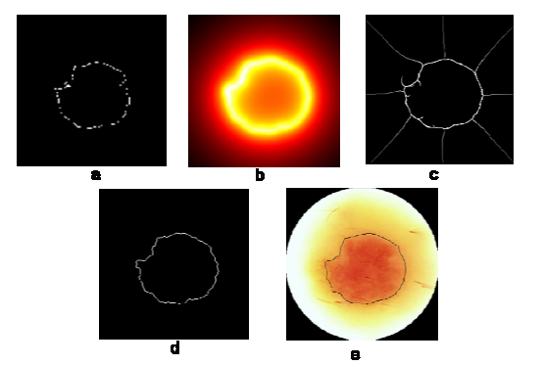

Fig. 8. Boundary smoothing algorithm. (a) Original boundary, (b) boundary from the basis functions, (c) minor ridges, (d) smooth boundary, and (e) smooth boundary superimposed on the original color image.

D.8 Validation of segmentation results

To validate the automatic procedures we compared the automatic segmentation results with manual segmentation by an expert (NM), obtained using Image J [43], which was used to draw lesion boundaries on the images and measure the segmented areas. To quantify the error between manual and automatic segmentation in estimating the lesion area, we computed an error [41] by first overlaying the automatically segmented area on the corresponding manually segmented area and then computing the ratio between the areas that do not overlap and the sum of the two areas. Using the manual segmentation as the gold standard, the error of an automatic method is given by

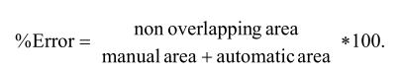

Regardless of the size of a lesion this error varies between 0%, when the automatic and manual segmentations match exactly and the numerator becomes zero, and 100%, when the two segmentation results do not overlap at all.

To decide whether an image was correctly segmented, we used an error value of 18% as the cut-off threshold. This value was based on a previous study [41] that showed that if the same image is manually segmented by four experts, the average variability over 20 lesions among the experts was 8.5%, and the inclusion of an additional tolerance of 10% , since outlining the lesion with a single-pixel precision is not clinically critical.

D.9 Determining Malignancy

To determine whether a lesion is malignant or not, after segmenting the TLM and XLM images of the lesion, two measures of area discrepancy across the two modalities are computed, namely the ratio of TLM and XLM areas, and the normalized area difference, which is defined as

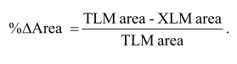

The original dataset consisted of 60 pairs of images that were free of heavy pen-markings and contained thee ntire lesion. However, nine XLM images were excluded from the analysis, since no pigmentation area could be identified for manual segmentation by the expert, resulting in a total of 51 of XLM and 60 TLM images, which underwent preprocessing, segmentation, and classification.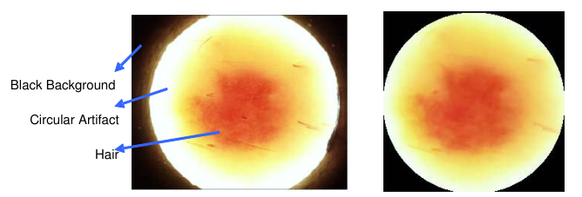

Fig. 9. Original (left) and processed image (right) after masking, cropping, and artifact attenuation.

1. Segmentation results

All TLM and XLM images were segmented by three different methods independently:Methods III and IV were applied to both TLM and XLM images, while Methods I and II were applied only to TLM and XLM images, respectively. In general, the XLM images showed less pronounced differences between lesion and background, because of the presence of the vasculature area. Thus, to identify the boundary, we used Method I to fit two Gaussians to the histogram of only the red channel, which would have the deepest tissue penetration and, therefore, would provide the best contrast. On the other hand, Method II was applied only to XLM images, since the method relies on a principal component transformation, which assumes a large difference in intensity values between lesion and background. Thus, XLM images, which show mostly surface pigmentation characteristics, are well suited for use with this method.

Figure 10 shows an example of a lesion imaged in the TLM (a) and XLM (e) modalities. The vasculature areas identified by Methods I, III, and IV, are shown in parts (b-d), respectively, while the pigmentation areas identified by Methods II, III, and IV, are shown in parts (e-h), respectively.

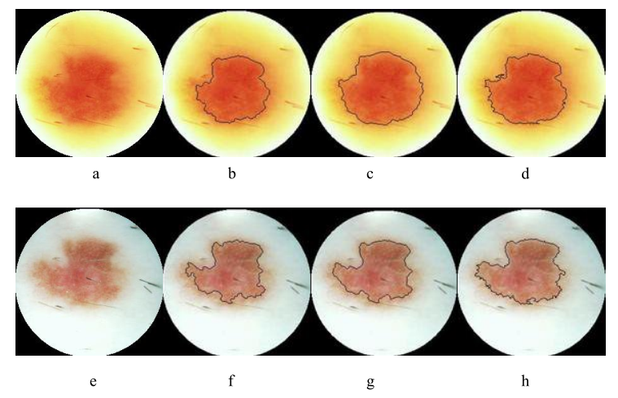

Fig. 10. (a) TLM and (e) XLM images of the same skin lesion; (b-d) the vasculature areas segmented using Methods I, III, and IV; and (e-h) pigmentation areas identified by Methods II, III, and IV.

Overall, 56 of the 60 TLM images and 47 of the 51 XLM images were segmented correctly by at least one method,as judged by visual inspection by the expert. Additionally, all these images met the criterion of less than 18% automatic segmentation error. Furthermore, 25 TLM and 25 XLM images were segmented correctly by all methods, while four TLM and four XLM images were segmented incorrectly by all methods. Tables 1 and 2 summarize the results obtained by the individual techniques in each imaging modality. As it can be seen, Method IV had the best overall performance for both TLM and XLM images, showing 76.6% and 84.3% success rate, respectively.

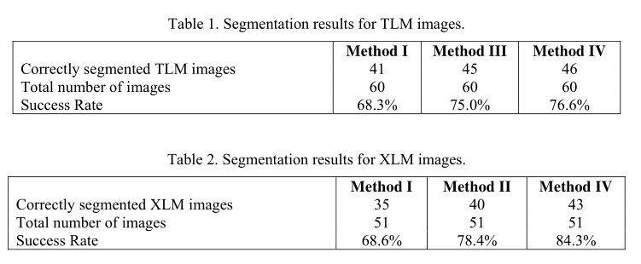

1. Scoring Stage

After segmenting the TLM and XLM images individually, the scoring stage selected one of the three segmented images as the final result, based on the set of criteria mentioned earlier. In all cases in which at least one method gave correct results, the scoring stage was able to select the correct answer. Figure 11 shows an example in which only one method achieved correct segmentation of a TLM image, while the other two failed; yet, the scoring stage was able to select the correct segmentation as the final result.

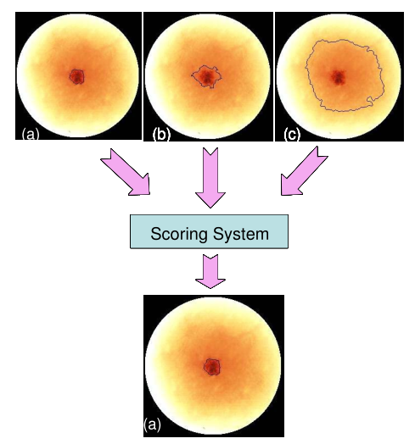

Fig. 11. Example of a TLM image segmented with three different methods (top row), and final result selected by the scoring stage (bottom).

The usefulness of the scoring stage is summarized in Table 3, which shows that the overall performance of the system that includes the scoring stage was increased to 93.3% and 92.2%, for the XLM and TLM images, respectively, providing a 21.6% and 9.3% net improvement, respectively.

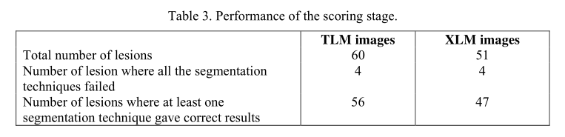

D. Validation of segmentation results

The system performance was quantified by computing a percent error between automatic and manual segmentation, separately for each image, in each imaging modality. An example of automatic and manual segmentation of a TLM image is shown on the left and right panels of Figure 12, respectively.

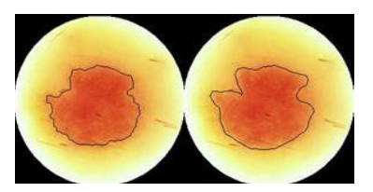

Fig. 12. Example of automatic (left) and manual (right) segmentation of a lesion.

The average error was also computed for the images correctly segmented by all methods and for the final result image selected by the scoring system. These results are summarized in Table 4, where it can be seen that the two-stage system had a lower error ratio than each individual method, in both imaging modalities.

Table 4. Average error ratio for each segmentation method and the scoring stage in each imaging modality.

Malignancy detection

A total of 40 lesions that had both the TLM and XLM images correctly segmented by the automatic procedures were further analyzed for assessing malignancy. The lesions were categorized as Benign, Compound Nevi, Dysplastic Nevi, or Melanomas, based on data from pathology. Table 5 summarizes for each lesion the TLM and XLM area measurements, the TLM/XLM ratio, the percent TLM area change, the exact description of the lesion by the dermatologist, and the final lesion classification by pathology.

Table 5. Area difference across the TLM and XLM modalities for various types of skin lesions.

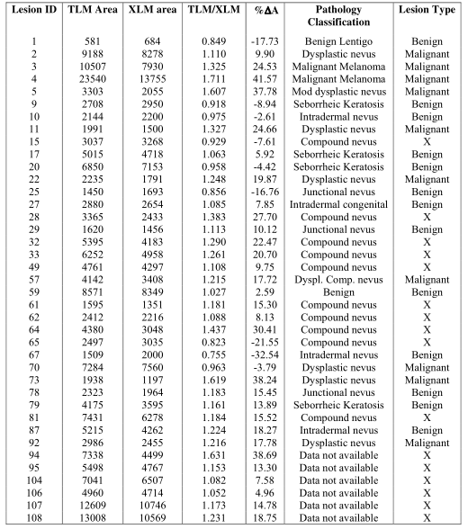

Typically, the malignant lesions show a much larger area in the XLM image that corresponds to blood vessels developed to support the growing cancer, while the benignlesions show approximately the same area in both images. Figure 13 shows the difference between a malignant and a benign lesion in the TLM and XLM imaging modalities. The lesions in the upper row represent a mild dysplastic nevus, while the images in the lower row correspond to a compound nevus. Core idea: Build two deep networks with more than 50 layers. One is to use FCRN (Fully convolutional residual network) to segment melanoma. Originally, FCRN was used for classification, but the original downsampling was changed to upper sampling, and deconvolution was used instead of upper sampling to make the output image and the original image size And so on, because downsampling is used in the classification, the output becomes a one-dimensional vector. The innovation of FCRN is in building residual blocks. The DRN (deep residual network) network is used for classification, and this step takes the segmentation results as the input image, reducing the preprocessing step. Changes in this network structure The average subsampling of 7 * 7 is used to closely follow the residual block to extract the global depth residual features. The average of the two classifiers (Softmax classifier and SVM) is taken to get the end

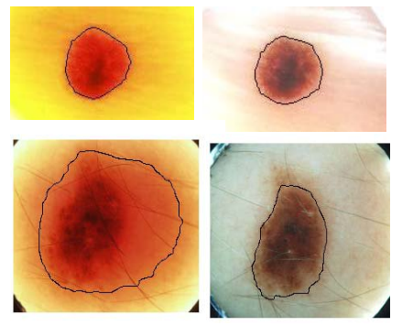

Fig. 13. TLM (left column) and XLM (right column) images of benign (upper row) and malignant (lower row) lesions. Notice the increase in area in the malignant lesion.

The average values of the ratio between the TLM and XLM areas and the percent change in area when only lesions with results confirmed by pathology are used are summarized in Table 6, which shows clear mean differences between benign, malignant and, dysplastic nevi. Thus the area difference can be use as a criterion for malignancy.

Table 6. Average increase in TLM area of the skin lesions categorized by lesion type.



If the lesions without pathology results are ignored, and excluding the dysplastic nevi which can become either malignant or benign, the remaining 23 lesions are either malignant or benign. In this case, a simple threshold for the %∆A parameter at 1.2 can separate almost all benign lesions from the malignant ones. More specifically, the 23 lesions classified as shown in the confusion matrix reported in Table 7, which shows a sensitivity of 80%, specificity of 92.3%, and an overall accuracy of 86.9% in determining the malignancy of a lesion.

Table 7. Overall performance of the system.

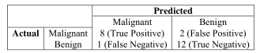

research technique:

In multiple deep learning frameworks, Convolutional neural networks can realize the features Mapping shift invariance, suitable for where It has displacement, scaling and twist invariant Two-dimensional graphs of the sex. So far, the volume Product neural networks in image recognition and division Class and other aspects to show a strong ability, Recognition from the handwriting form [18] To the Image- The classification of Net image [19], detection accuracy far beyond traditional algorithms, has been Close to or above the level of human experts. The typical convolutional network contains the Multiple staggered convolutional layers and pooling layers, and then connect several full companies Connect the layer. The fully connected layer can map the feature map produced by the convolution layer into one A fixed length feature vectors suitable for the classification and back of images return. The full connection layer in the network structure is replaced with a convolution layer to form the whole layer Convolutional network, it is suitable to solve the problem of image segmentation. 2.2 residual network For deep learning models, a deeper network structure means more Strong characteristic abstraction ability. But before 2015, the deepest network There are only 22 layers of [20], because the designed model will come out at a certain depth Now saturated, resulting in a decrease in accuracy. To address this problem, He et al. [21] The deep residual network uses shortcut connection (short- cut connections) Method, breaking with the traditional neural network n-1 layer The output can only be given to the n layer as an input convention, making a certain layer lose Out can be directly crossed over several layers as an input to a later layer, for the stack The phenomenon of saturation caused by adding multilayer networks provides a solution. 2.3 Transfer learning method Deep neural networks include a large number of training parameters to prevent the network Complex overfitting, to obtain effective generalization ability, must utilize a large number of bands Label data is trained in many fields, including the medical industry It is often difficult to meet the need of direct training.to this end,Pan And [22] proposed transfer learning methods, for medical image analysis problems, Figure 1. Conventional representation of learning and depth learning contrast output Feature mapping feature import Feature mapping Abstract characteristics Simple characteristics import output (A) Conventional representation study (b) deep learning General Review Review 91 The depth model was trained with million-level natural images Parameters of the neural network and then through smaller domain-specific datasets Fine-tuning of the parameters. Hoochang et al Can also achieve a very good accuracy, can meet the needs of medical image processing ask.

IV. C ONCLUSIONS AND D ISCUSSION

Skin cancer is the most common of all cancers and represents about one half of all new cancers detected. Approximately 1.2 million new cases of skin cancer are being detected in the United States each year. About 80% of all skin cancers are basal cell carcinomas, 16% are squamous cell carcinomas, and 4% are melanomas. Melanoma is the deadliest of the skin cancers, accounting for over 7300 cancer deaths per year in the United States. The incidence of melanoma in the United States increased by 3% between 1997 and 1998 and approximately44,200 new cases of malignant melanoma were detected in 1999 [1].

Early detection of skin cancer is of paramount importance. If detected at an early stage, skin cancer has one of the highest cure rates, and in most cases, the treatment is quite simple and involves excision of the lesion. Moreover, at an early stage, skin cancers are very economical to treat, while at a late stage, cancerous lesions usually result in near fatal consequences and have a extremely high costs associated with the necessary treatment. For example, melanomas, the deadliest form of all skin cancers, account for 75% of all cancer deaths [1-4]; however, when detected at an early stage, the cure rate is higher than 95%.

We have developed a methodology that can automatically segment a lesion and accurately measure boththe pigmentation and vasculature related characteristics. Independently, the success rate of correct segmentation of each of these techniques is in the order of 75%, but the additional stage that combines results from all three methods and a set of ad hoc criteria increased the success rate to 95%. Our approach can have a significant impact in the field of cancer research. More specifically, our procedures can result beneficial to the patients that undergo screening by replacing the current imaging procedures, which are inherently limited and liable to subjective interpretation, with an automatic and unbiased approach that extracts the maximum amount of information from a lesion and helps the physician make a correct diagnosis. This can result in a more accurate diagnosis, safer surgical treatment, improved quality of life for the patients, and at the same time decreases the cost of health care delivery.

These results provide strong support for using transillumination imaging in the early diagnosis of skin cancer.

According to the diagnostic criteria, skin tumors can be divided into three categories: benign, low-grade and highly malignant. For highly malignant skin tumors, if not detected in time, it will seriously harm the health of patients. However, in clinical practice, the differentiation of malignancy requires biopsy and pathological examination and is time-consuming. Moreover, in many areas, it is very inconvenient for patients to go to the hospital for examination due to the severe shortage of dermatologists. Therefore, a simple and easy screening method for skin malignancy is urgently needed. In this paper, we spent 5 years on a dataset containing 4500 images of 10 kinds of skin tumors. All cases were pathologically confirmed; secondly, we classified each case as low risk, high risk, or high risk, with borderline nevus, intradermal nevus, dermatofibroma, lipoma, and seborrheic keratosis at low risk, and basal-cell carcinoma, Bowen's disease, and actinic keratosis at low risk. High-risk, squamous cell carcinoma and malignant melanoma are dangerous; third, we applied abnormal structures to establish a risk classifier. The area under the curve (auc) of the three hazards is 0.959,0.919, and 0.947, respectively. To further evaluate the validity of the proposed risk degree classification, we conducted a competition with 20 professional dermatologists. The results show that the classifier performs better than the dermatologists. Our system contributes to patient screening. It can identify patients at risk and remind them to go to the hospital for further tests.R EFERENCES.

Kawahara et al [35] utilize convolutional network pairs of multiresolution channels Images with diseased tissue were classified The algorithm can only handle the limitation of a single resolution image and can utilize different Images of the pixels are processed as input. Ge et al [36] in the algorithm Considering the global and local features, the deep residual network is used The global information and bilinear pooling techniques with local information, in Mo- Good results were obtained on both the leMap and ISIC 2016 data sets. Abbas et al [37] uses a convolutional network to extract image features and then use the base Autoencoder at the stack (stack-based autoencoders, SAE) The features were purified and finally using a SoftMax linear classifier pair Melanocytes and non-melanocytes were sorted. The algorithm was implemented at 5,200 It was performed on a clinical image, and the test accuracy reached 91.5%. Since the dermoscopic image dataset tends to be small and the cases are heterogeneous Figure 2 Schematic representation of the lesion segmentation, [25] Table 1 Image segmentation algorithms for melanoma detection and their evaluation of the results Algorithm feature dataset Evaluation of results Accuracy /% sensitivity /% specificity /% The FCN [25] FCN + rotation training set picture

Multi-level fully convolutional network The FCN [27] FCN + is superpixel-based The fine-tuning ISIC 2016 92.3 — — FCN [28] FCN + based on Jkard Cost function of the distance ISIC 2016 95.5 91.8 96.6 CDNN [29] CDNN + smaller convolution Nuclear + color information ISIC 2017 95.7 92.4 96.5 FrCN [30] is exempted from image preprocessing or Post-processing operation ISIC 2017 94.6 91.6 96.5 DDN [31] DDN + multipath depth Refining the network ISIC 2017 96.0 — — Figure 3 The classified dermoscopic image [34] Note: Accuracy is the percentage of the sum of positive samples to the total samples Sensensation is the percentage of the number of correctly segmented positive samples and all positive samples; specificity is the correctly segmented shade Percentage of the number of sexual samples compared to the number of all negative samples (a) melanoma (B) Benign tissue (A) The target area passes through the red line segmentation. (b) the binary template after image segmentation General Review Review 92 In November 2018, Volume 39, Issue 11 Chinese Medical Equipment Journal Vol. 39 No.11 November 2018 Heng, Vasconcelos et al. [38] designed a deep convolutional neural network (deep convolutional neural networks, DCNN) to divide it up Class, which achieved a good balance in specificity and sensitivity.March- The ability of [39] for 10 different algorithms for melanoma diagnosis by etti et al Forces were compared, including the top ranking in the ISIC 2016 competition 5 algorithm and the other 5 algorithms (2 non-learning algorithms And 3 machine learning algorithms), randomly selected 100, zhang skin The mirror images were tested and the results show that the best algorithm The iation is close to human experts (62% VS 59%), but human Home specificity is lower than the fusion of different algorithms (59% VS 76%). The study further concluded that the deep learning system works on the skin The recognition of melanoma in microscopic images exceeds in some humans specialist. Codella et al [40] for a variety of classification methods (including manual compilation Feature extraction, sparse coding, convolutional neural network, deep Degree residual network and fully convolution U-Net) on the ISIC, dataset For evaluation, the results show the accuracy and specificity of the optimal algorithm The degree is higher than human experts, and the sensitivity is comparable to human experts.Esteva And other [15] collected 129450 from different publicly available databases and Stanford Hospital A clinical dermoscope picture, using Google Tensorflow platform [34], base In the Inception v3 CNN algorithm structure, the application of transfer learning side Method for testing,

Test results with 21 certified skin diseases Experts compare, the results show that deep learning algorithms can achieve with A able level of dermatologists. The particular feature of the study is its adoption One hundred thousand levels of data, more so than past studies Suit force. In China, Li [41] and Li Hang [42] adopt two deep full Convolutional residual network (fully convolutional residual networks, FCRN) were segmented and classified separately, using a convolutional network for special Zheng extraction, and melanoma detection based on the ISIC 2017 dataset Measurement, to achieve a better detection effect. Yu et al [43] designed over 50 The convolutional network of the layer is classified in order to overcome the training data deficiency To overfitting, residual learning is used to prevent the gradient from disappearing and simultaneously constructed An FCRN was created for the segmentation of the lesions, with a deep residual network collaterals (deep residual networks, DRN) is used to segment the images Classification, combined with 2 networks to form a 2-level framework. The algorithm was implemented in ISIC The test on the 2016 dataset and achieved the first place on the classification problem The score of the name. Xie et al. [44] proposed using self-generated neural network (self- generating neural network, SGNN) and divided the focal area Cut, and the threshold method was used to divide the focal areas into diffusion areas and internal lesions Regions and extracted features in 2 regions to design a neural network Complex Integration Model (neural network ensemble model, NNEM) Lesions were sorted and models presented separately for yellow collected at Air Force General Hospital Species dataset and Caucasian datasets collected from PH 2 and EDRA On the test, the test results outperform the other integrated models. The first study To distinguish between different skin background colors,

[1] Abidi M. and Gonzales R., Eds., “Data Fusion in Robotics and Machine Intelligence”, New York Academic, 1992.

[2] Alexander A., Nazarian N. M., Capuzzi D. M., Rawool N. M., Kurtz A. B., and Mastrangelo M.J., “Color Doppler sonography detection of tumor flow in superficial melanoma metastases: histologic correlation”, J. Ultrasound Med.,

vol. 17, 123-126, 1998.

[3] Anonymous authors, “American Cancer Association and the American Academy of Dermatology”, Web publications,

2001.

[4] Binder M., Schwarz M., Winkler A., Steiner A., Kaider A., Wolff K., and Pehamberger H., “Epiluminescence Microscopy. A useful tool for the diagnosis of pigmented lesions for formally trained dermatologists”, Arch. Dermatology, vol. 131, 286-291, 1995.

[5] Binder M., “Skin Examination Device”, US Patent Number 6,032,071, Published in 2000.

[6] Bischof L., Talbot H., Breen E., Lovell D., Chan D., Stone G., Menzies S., Gutenev A., and Caffin R., “An Automated Melanoma Diagnosis System”, New Approaches in Med. Image Analysis, SPIE, vol. 3747, 130-141, 1999.

[7] Brochez L., Verhaeghe E., Bleyen L., and Naeyaert J. M., “Diagnostic ability of general practitioners and dermatologists in discriminating pigmented skin lesions”, J. Am Acad. Dermatology, vol. 44, 976-86, 2001.

[8] Cancer facts and figures 2002, “American cancer society”, Atlanta, Georgia, 2002.

[9] Claridge E., Hall P. N., Keefe M., and Allen J. P., “Shape analysis for classification of malignant melanomas”, J. Biomed. Eng., vol. 16, no. 3, 191-197, 1992.

[10] DeCoste S. D., and Stern R. S., “Diagnosis and treatment of nevomelanocytic lesions of the skin. A community based study”, Arch. of Dermatology, vol. 129, no. 1, 57-62, 1993.

[11] Detmar M., “Tumor angiogenesis”, J. Investig. Dermatology Symp. Proc., vol. 5, 20-23, 2000.

17

[12] Dhawan A. P., Gordon R., and Rangayyan R. M., “Nevoscopy: Three-dimensional computed tomography for nevy and melanoma by side-transillumination”, IEEE Trans. in Med. Imaging, MI-3, 54-61, 1984.

[13] Dhawan A. P., “Apparatus and method for skin lesion examination”, US Patent Number 5,146,923, 1992.

[14] Dhawan, A. P., Gordon R., and Rangayyan R. M., “Computed tomography by side-transillumination to detect early

melanoma”, IEEE Annual Conf. Proc. of Eng. in Med., 518-522, 1984.

[15] Dhawan A. P. and Sicsu A., “Segmentation of images of skin lesions using color and texture information of surface pigmentation”, Computerized Med. Imaging and Graphics, vol. 16, no. 3, 163-177, 1992.

[16] Doshi M., Duvic M., Mullani N., and Zouridakis G., “Early diagnosis of skin cancer based on measuring vascularization and pigmentation in Nevoscope images”. Abstracts of the Annual Houston Conf. on Biomed. Eng., 2004.

[17] Duda R., Hart P. and Stork D. “Pattern Classification”, Wiley Publication, second edition, 2000.

[18] Ganster H., Pinz A., Rohrer R., Wildling E., Binder M., and Kittler H., “Automated Melanoma Recognition”, IEEE Trans. on Med. Imaging, vol. 20, no. 3, 233-239, 2001.

[19] Gee M. S., Saunders H. M., Lee J. C., Sanzo J. F., Jenkins W. T., Evans S. M., Trinchieri G., Sehgal C. M., Felman M. D., and Lee W. M., “Doppler ultrasound imaging detects changes in tumor perfusion during antivascular therapy associated with vascular anatomic alterations”, Cancer research, vol. 61, 2974-2982, 2001.

[20] Giovagnorio F., Andreoli C., and De Cicco M. L., “Color doppler sonography of focal lesion of the skin and subcutaneous tissue”, J. Ultrasound Med., vol. 18, 89-93, 1999.

[21] Gloster H. M., and Brodland D. G., “The epidemiology of skin cancer”, Dermatology Surg., vol. 22, 217-226, 1996.

[22] Goldsmith L. A, Koh H. K, Bewerse B. A., Reilley B., Wyatt S.W., Bergfeld W.F., Geller A.C., and Walters P. F.,

“Proceedings from the national conference to develop skin cancer agenda ”, CDC 1995.

[23] Goshtasby A., “Fitting Parametric Curves to Dense and Noisy Points”, Presented at 4th Int’l Conf. Curves and Surfaces,

1999.

[24] Green A., Martin N., Pfitzner J., O’Rouke M., and Knight N., “Computer image analysis in the diagnosis of melanoma”,

J. American Acad. of dermatology, vol. 31, no. 6, 958-964, 1994.

[25] Hance G. A., and Umbaugh S. E., Moss R. H., and Stoecker W. V., “Unsupervised color image segmentation”, IEEE Eng. Med. Biol. Mag., vol. 15, no. 1, 104-111, 1996.

[26] Kelly J. W., Yeatman J. M., Regalia C., Mason G., Henham A. P., “A high incidence of melanoma found in patients with multiple dysplastic nevi by photographic surveillance”, MJA, vol. 167, no. 4, 191-194, 1997.

[27] Mullani N. A., Talpur R., Apisarnthanarax N., Weinstock M., Drugge R., Ahn C., Prieto V. G., and Duvic M., “Side- transillumination epiluminescence imaging for diagnosis of dysplastic nevi and melanoma. A comparison to oil and cross-polarization epiluminescence imaging”, in press.

[28] Nachbar F., Stolz W., Merkle T., Cognetta A. B., Vogt T., Landthaler M., Bilek P., Braun-Falco O., and Plewig G., “The ABCD rule of dermatoscopy. High prospective value in the diagnosis of doubtful melanocytic skin lesions”, J. Am Acad. of Dermatology, vol. 30, no. 4, 551-559, 1994.

[29] Nevoscope web site at [www.n](http://www.n)evoscope.com.

[30] Otsu N., “A Threshold Selection Method from Gray-Level Histograms”, IEEE Trans on Systems, Man, and Cybernetics, vol. 9, no. 1, pp. 62-66, 1979.

[31] Pehamberger H., Steiner A., and Wolff K., “In vivo epiluminescence microscopy of pigmented skin lesions. I. Pattern analysis of pigmented skin lesions”, J. Am Acad. Dermatology, vol. 17, no. 4, 571-583, 1987.

[32] Perelman R.O., “An estimate of the incidence of malignant melanoma in the United States. Based on a survey of members of the American Academy of Dermatology”, Dermatologic Surgery, vol. 21, no. 4, 301-305, 1995.

[33] Roberts M. E. and Claridge E., “An artificially evolved vision system for segmenting skin lesion images”, MICCAI, LNCS 2878, 655-662, 2003.

[34] Sonka M., Hlavac V., and Boyle R., “Image processing, analysis, and machine vision”, Brooks Cole, Second edition, 1998.

[35] Stolz W., Riemann A., Przetak C., Bilek P., Landthaler M., Braun-Falco O., Holzel D., and Abmayr W. “Multivariate analysis of criteria given by dermatoscopy for the recognition of melanocytic lesions”, Book of Abstracts, Am Acad. Of Dermatology Meeting, Dallas, 53, 1991.

[36] Tur E., and Brenner S., “Cutaneous blood flow measurement for the detection of malignancy in pigmented lesions”, J. Dermatology, vol. 184, no. 1, 8-11, 1992.

[37] Umbaugh S. E., Moss R. H., Stoecker W. V., and Hance G. A., “Automatic color segmentation algorithms: With application to skin tumor feature identification”, IEEE Eng. Med. Biol. Mag., vol. 12, no. 3, 75-82, 1993.

[38] Umbaugh S. E., Moss R. H., and Stoecker W. V., “An automatic segmentation algorithm with application to identification of skin tumor borders”, Comp. Med. Imaging and Graphics, vol.16, no. 3, 227-235, 1992.

[39] Umbaugh S. E., Moss R. H., and Stoecker W. V., “Automatic color segmentation of images with application in detection of variegated coloring in skin tumors”, IEEE Eng. Med. Biol., vol. 8, 43-52, 1989.

[40] Wolff K., Binder, and M., Pehamberger H., “Epiluminescence microscopy: a new approach to the early detection of melanoma”, Adv in Dermatology, vol. 9, 45-56, 1994.

[41] Xu L., Jackowski M., Goshtasby A., Roseman D., Bines S., Yu C., Dhawan A., and Huntley A., “Segmentation of skin cancer images”, Image and Vision Computing, vol. 17, 65-74, 1999. 18

[42] Zharkova V.V., Ipson S. S., Zharkov S. I., Benkhalil A. K., Aboudarham J., and Bentley R. D., “A full disk image standardisation of the synoptic solar observations at the Meudon observatory”, J. Solar Physics, vol. 214, no. 1, 89-105, 2003.

[43] http://rsb.info.nih.gov/nih-image/about.html.

[44] http://edcenter.med.cornell.edu/CUMC_PathNotes/Dermpath/Dermpath_07.html.

[45] http://www.bccancer.bc.ca/HPI/CME/SkinCancer/CMESkinCancer/Readings/Prevention/

DysplasticNevus.htm.

[46] http://mathworld.wolfram.com/FullWidthatHalfMaximum.html

[47] Shankar A. Automatic Segmentation of PET Images and Volumetric Measurement of Metabolic Activity, MS Thesis, University of Houston, 2004.

[48] Doshi M. Automatic Segmentation of Skin Cancer Images, MS Thesis, University of Houston, 2004.

[49] BURDICK J，MARQUES O，ROMEROLOPEZ A，et al. The impact of segmentation on the accuracy and sensitivity of a melanoma classifier based on skin lesion images[C]//The SIIM

2017 Scientific Program，June 1-3，2017，Pittsburgh. Pitts- burgh：Society forImaging Informatics in Medicine，2017：25- 30.

[50] BURDICK J，MARQUES O，WEINTHAL J，et al. Rethinking skin lesion segmentation in a convolutional classifier[J]. J Di- git Imaging，2017，9（2）：1-6.

[51] ABADI M，AGARWALA，BARHAM P，et al. Tensorflow：lar- gescale machine learning on heterogeneous distributed sys- tems[EB/OL]. [2018-08-02].

[52] KAWAHARAJ，HAMARNEH G. Multi-resolution-tractCNN with hybrid pretrained and skin-lesion trained layers[C]//The International Workshop on Machine Learningin Medical Ima-

ging，October 17-21，2016，Athens. Athens：Springer，2016：164-171.

[53] GE Z，DEMYANOV S，BOZORGTABAR B，et al. Exploiting local and generic features for accurate skin lesions classifi- cation using clinical and dermoscopy imaging[C]//2017 IEEE 14th International Symposium on Biomedical Imaging，April18-21，2017，Melbourne. Melbourne：IEEE，2017：11-14.

[54] ABBAS Q. Development of a clinically-oriented expert sys-tem fordifferentiating melanocytic from non-melanocytic skin lesions[J]. Development，2017，8（7）：24-29.

[55] VASCONCELOS C N，VASCONCELOS B N. Experiments using deep learning for dermoscopy image analysis[J]. Patt-ern Recognit Lett，2017，16（3）：68-77.